

DOCUMENTATION FOR

Strem Base

**TEAM MEMBERS (MegStream)**

Hasaan M Adam,

Bushra M Zubair,

StreamEase Dashboard Design Documentation

**1. Introduction**

The StreamEase dashboard is a pivotal component of the platform, designed to provide users with a comprehensive overview of their streaming services and subscriptions. This document outlines the design, functionality, and user interactions of the dashboard, ensuring it meets the specified requirements and delivers a user-friendly experience.

**2. Dashboard Overview**

The StreamEase dashboard serves as the central hub for managing streaming subscriptions and tracking favorite shows. It features an organized layout that displays key information at a glance, facilitating easy navigation and interaction.

2.1 Key Components

Subscription Summary: Displays an overview of active subscriptions, including service names, plans, and renewal dates.

Favorite Shows: Highlights recently marked favorite shows with quick access to their details.

Upcoming Reminders: Lists upcoming show schedules and subscription renewal reminders.

Navigation Menu: Provides access to various sections such as Manage Providers, Manage Subscriptions, and Settings.

**3. Design Elements**

**3.1 Layout and Structure**

Dashboard Grid Layout: The dashboard utilizes a grid layout to organize information into visually distinct sections. Each section is represented as a card or tile, making it easy for users to scan and interact with the data.

Subscription Summary Section: Features a grid of cards, each representing a different streaming service. Each card includes key details such as the service name, plan type, and renewal date.

Favorite Shows Section: Displays a horizontal scrollable list of favorite shows with cover images and titles.

Upcoming Reminders Section: Shows a list of upcoming reminders for show schedules and subscription renewals.

Typography and Color Scheme: Utilizes clear, legible fonts and a consistent color scheme to ensure readability and visual appeal. Emphasizes key information with bold text and highlights.  
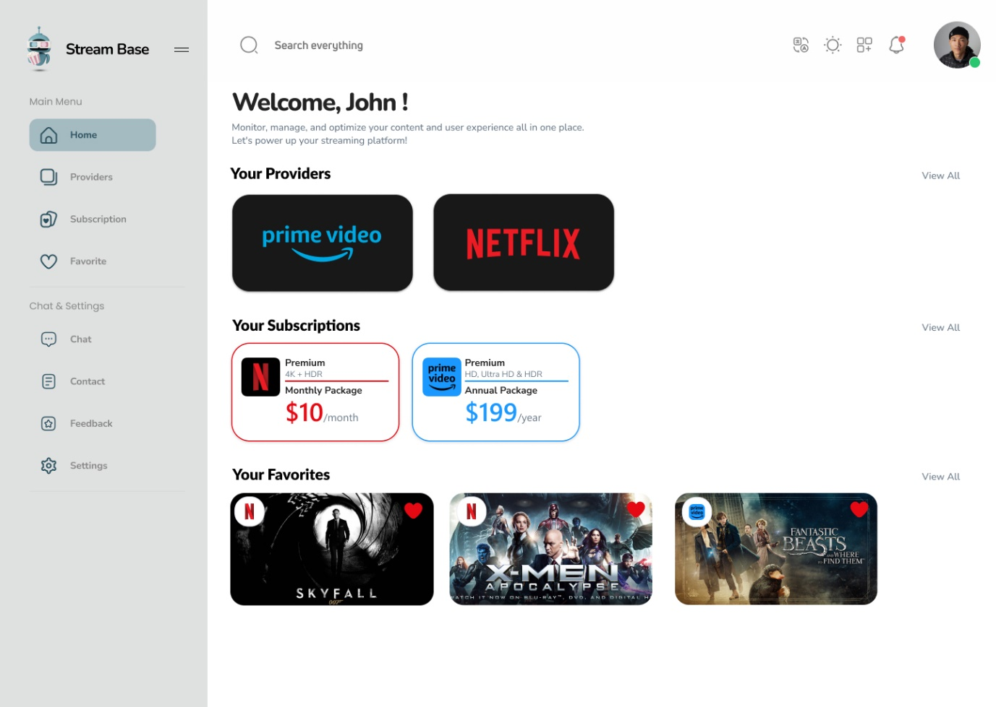

**3.2 Visual Design**

Cards and Tiles: Use of cards to present information about subscriptions and favorite shows. Each card includes icons, images, and text to convey relevant details.

Icons and Buttons: Incorporates icons for quick actions (e.g., edit, delete) and buttons for adding new subscriptions or shows.

Responsive Design: The dashboard adjusts to various screen sizes, ensuring a seamless experience on both desktop and mobile devices.

**4. User Interactions**

**4.1 Subscription Summary**

Viewing Subscriptions:

Interaction: Users can view a summary of all active subscriptions at a glance. Each card provides essential details such as service name, current plan, and next renewal date.

Actions: Users can click on a subscription card to access detailed information or make changes to the subscription.

Managing Subscriptions:

Interaction: Users can interact with buttons or icons on each card to edit or delete subscriptions.

Actions: Editing allows users to update plan details or renewal dates, while deleting removes the subscription from the dashboard.

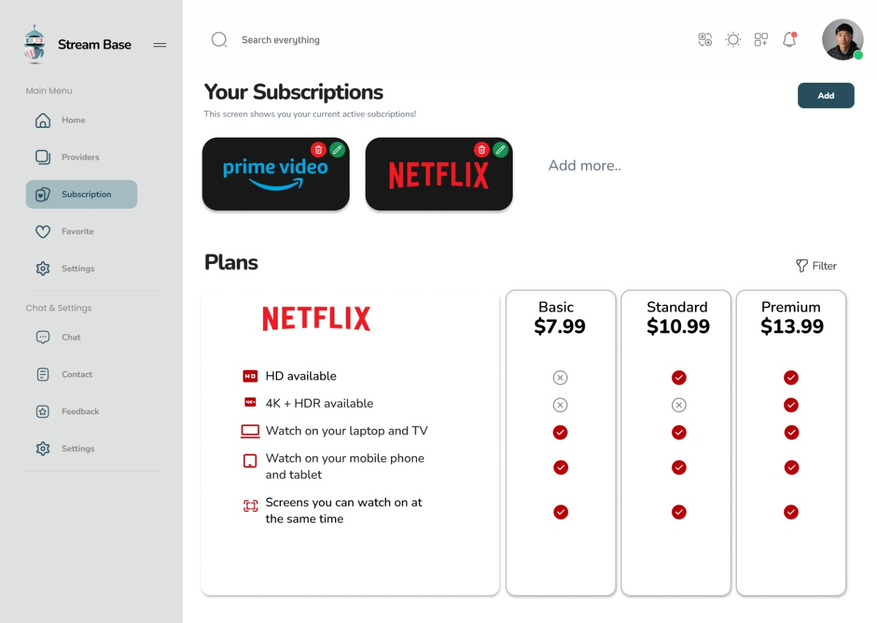

4.2 Favorite Shows

Marking and Unmarking Favorites:

Interaction: Users can mark shows as favorites by clicking on a star icon. Unmarking is equally straightforward with a simple click on the same icon.

Actions: Favorite shows are highlighted in the dashboard, allowing users to quickly access them.

Viewing Favorite Shows:

Interaction: Favorite shows are displayed in a scrollable list with cover images and titles.

Actions: Users can click on a show to view more details or access related content.  
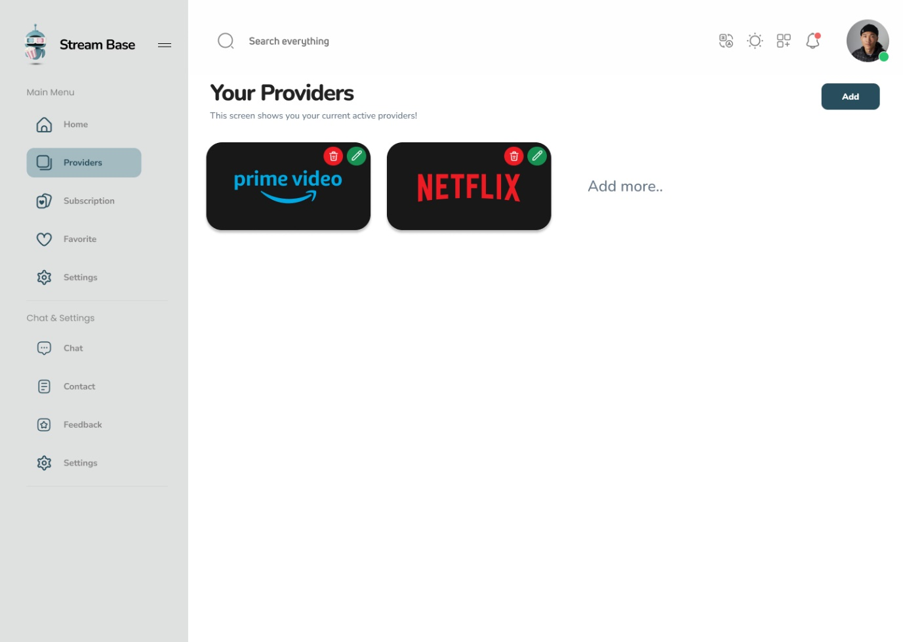

**4.3 Upcoming Reminders**

Viewing Reminders:

Interaction: The reminders section displays upcoming show schedules and subscription renewal dates.

Actions: Users can click on reminders to view detailed information or adjust settings for notifications.

Setting and Managing Reminders:

Interaction: Users can set new reminders directly from the dashboard using a dedicated button or form.

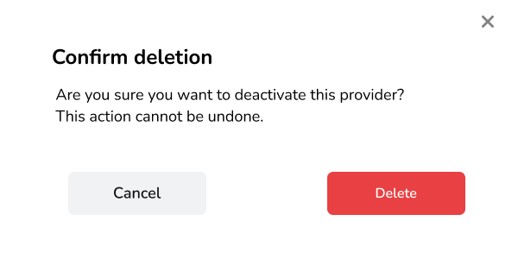

Actions: Users can manage existing reminders by editing or deleting them as needed.  
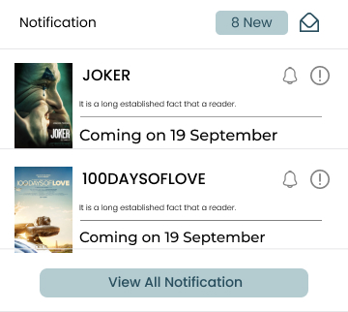

**4.4 Navigation Menu**

**Accessing Sections:**

Interaction: The navigation menu is either sticky or positioned as a sidebar, allowing users to access different sections of the website from any point on the dashboard.

Actions: Clicking on menu items directs users to sections such as Manage Providers, Manage Subscriptions, and Settings.

User Experience:

Interaction: The menu is designed for intuitive use, ensuring that users can easily find and navigate to the desired sections without confusion.  
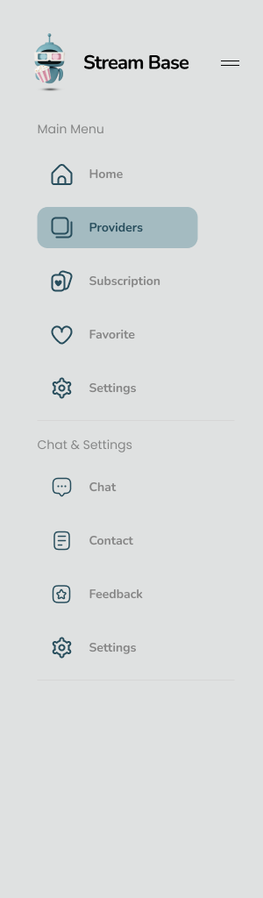

**5. Technical Specifications**

**5.1 Performance**

Loading Speed: The dashboard is optimized for fast loading times, ensuring that users can access their information quickly.

Responsiveness: The design is tested across various devices and screen sizes to maintain a consistent user experience.

**5.2 Accessibility**

Font Sizes and Colors: Ensures text is legible with appropriate font sizes and color contrasts.

Navigation and Interaction: Designed to be navigable using keyboard shortcuts and screen readers, providing accessibility for users with disabilities.

**5.3 Compatibility**

Browser Support: The dashboard is compatible with the latest versions of major browsers including Chrome, Firefox, Safari, and Edge.

Device Compatibility: Tested for compatibility across desktop and mobile devices to ensure a consistent experience.

**6. Conclusion**

The StreamEase dashboard is designed to be a central hub for managing streaming subscriptions and favorite shows. Its intuitive layout, user-friendly interactions, and responsive design ensure that users can efficiently track and manage their content. This documentation outlines the key aspects of the dashboard’s design, functionality, and technical considerations, providing a comprehensive overview of its implementation.